Gosper curves
The Gosper curve, named after Bill Gosper, also known as the flowsnake [1] (a spoonerism of snowflake), is a space-filling curve. It is a fractal object similar in its construction to the dragon curve and the Hilbert curve.
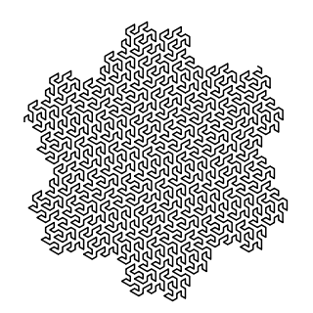
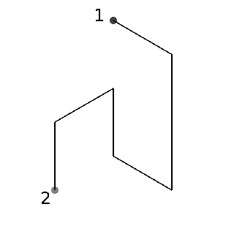

The line from the 2nd to the 1st point shows a single step of the Gosper curve construction. It can be made with varying initial angles, which makes the direction changes. Any automated program which can generate the curve fast enough can be given with a varying initial angle, will create a rotating gear effect with Gosper curve.
The space filled by the curve is called the Gosper Island. The first few iterations of it are shown below:
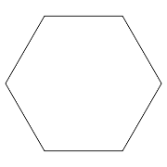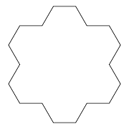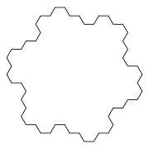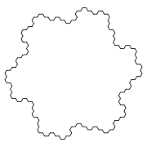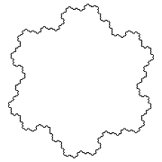
The Gosper Island can tile the plane. In fact, seven copies of the Gosper island can be joined together to form a shape that is similar, but scaled up by a factor of $\sqrt{7}$ in all dimensions. As can be seen from the diagram below, performing this operation with an intermediate iteration of the island leads to a scaled-up version of the next iteration. Repeating this process indefinitely produces a tessellation of the plane. The curve itself can likewise be extended to an infinite curve filling the whole plane.
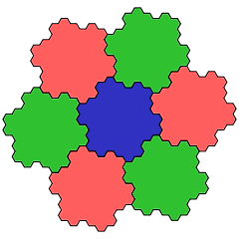

The Gosper Island is similar to Koch Snowflakes and most other Gosper Curves come under Peano Curves. Peano curves are space filling curves, i.e. a single curve twists and turns to fill an entire given space. We shall be working with Peano curves only later. However we are going to work with a Peano Gosper Curve in this chapter itself
Gosper Island
Workbook: Fractal/Finished Works/Worksheets/L system/Gosper Curves/Unexpanded/Gosper Island
The implementation of a Gosper Island is similar to that of a 3 segment Von Koch curve. The Gosper Island has an Angle2 rotation involved which is handled the way we handled the 3 segment Kioch Curve.
Have a look at the below figure to get an idea.
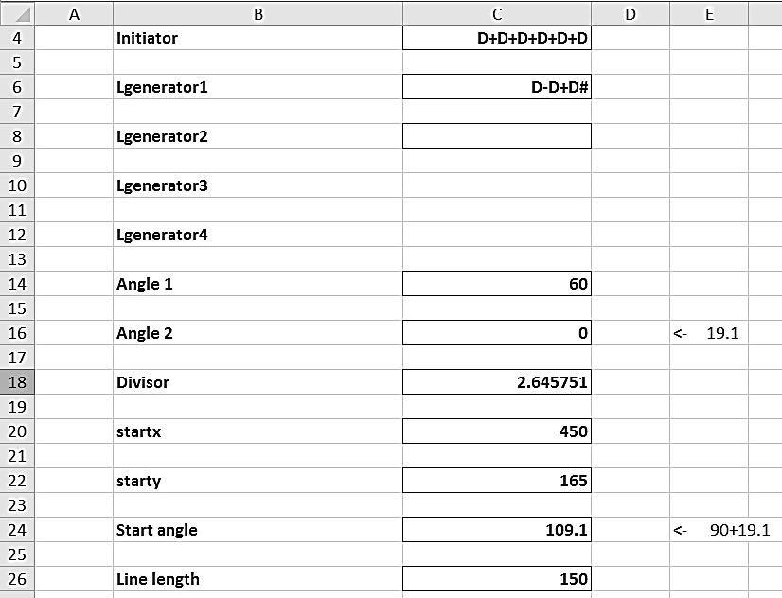
Here, like what we have done earlier, Angle2 is added with Start angle and is made 0.
The formulae are same as in 3 Segment Koch Curve. Level 1, 2 and 8 Gosper Curves are as shown below.
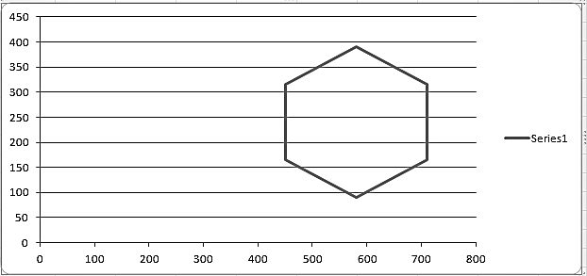

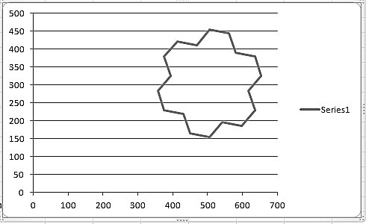

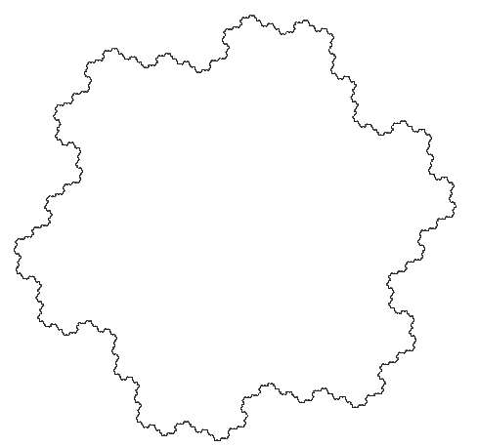

Peano Gosper Curve
Workbook: Fractal/Finished Works/Worksheets/L system/Gosper Curves/Unexpanded/Peano Gosper Curve
This is called a Peano Gosper Curve because it is a space filling curve as the level increases. Plotting a Peano Gosper curve is similar to that of a Koch Sierpinsky Triangle which we have seen earlier. Here too we have Right and Left patterns to deal with, but rest of the process is fairly straight forward.
Figure below shows the initial parameters of a Peano Gosper Curve
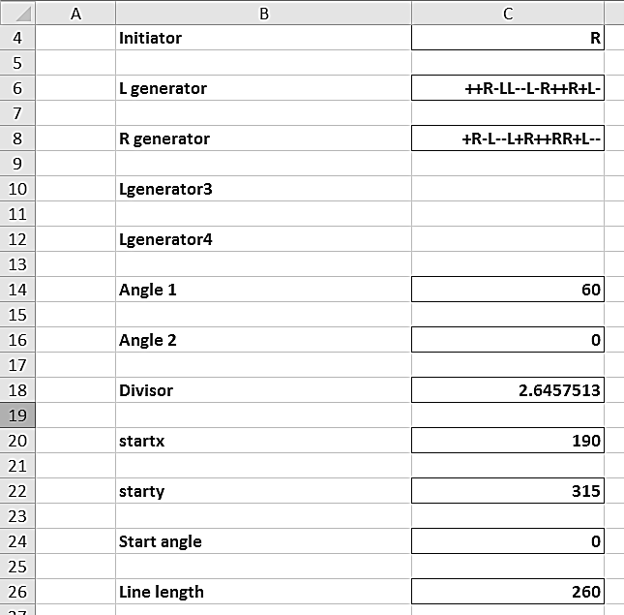
Substitution of strings is also similar. C32 contains the formula =SUBSTITUTE(C4,"R",$C$8) which substitutes the initiator with the Rgenerator. Cell C36 substitutes L with T and R with R generator and Cell C37 substitutes T with L generator. This is the same as how we did for Koch Sierpinsky.
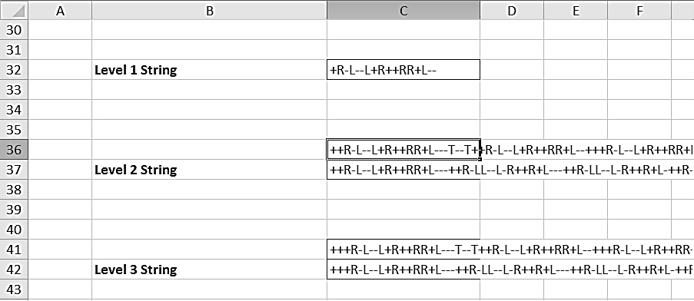
Upon generation and plotting, the Level 1, 2 and 5 looks like the below given figures
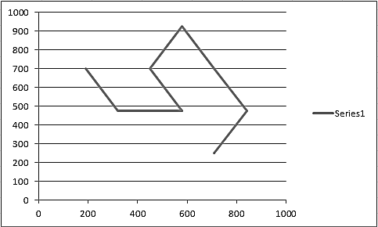
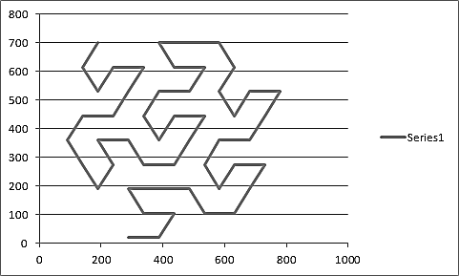
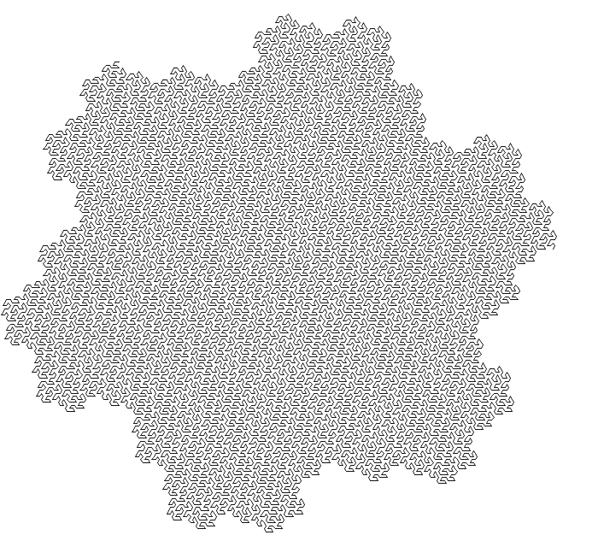

References
http://en.wikipedia.org/wiki/Gosper_curve

